Tour Divide 2019 Race Recap

This race recap of my participation in the 2019 edition of the Tour Divide is free to use for all my sponsors. It is allowed to edit it, meaning shortening and splitting it into pieces. It is not allowed to write any new text. If editing does occur, please send it to me for me to approve the editing.
Best regards,
Peter Sandholt
petersandholt76@yahoo.dk

This is a race recap of my participation in the 4.300 kilometers long Tour Divide. The race runs through the Rocky Mountain going from Banff in Canada, to Antalope Wells in New Mexico, USA. It is ridden as an unsupported race, meaning the riders have to do the ride without any support.
PRELUDE
As I sat on the plane on my way to Calgary, I didn´t really know what to expect. Tour Divide, a race I had wanted to ride for years, was just around the corner and I felt I had really put myself on the line. I didn´t really know where I was when it came to my fitness level. A lot of work and daily life hazzles had made it difficult to get the kilometers in. Well, this wasn´t the first time I felt this way before a race. What was even more worrying was, that my logistical planning was really at a halt. At least I felt well covered when it came to my equipment.
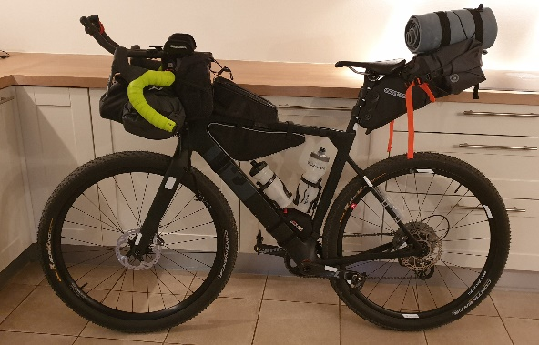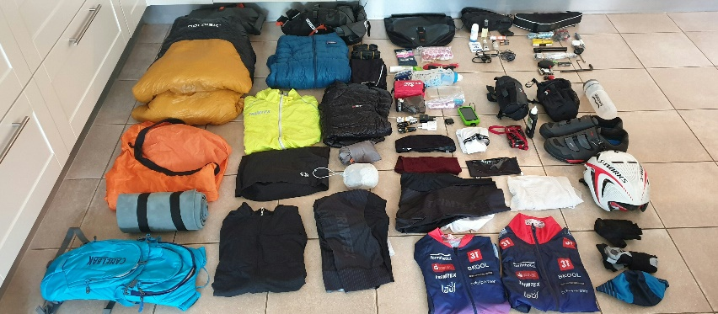
Arriving in Banff was a relief. I could barely believe that I was actually about to start the Tour Divide. Last minute buys and seeing all the other riders preparing their bikes made the days before the race quite intense. So many questions, so many “if´s”. I really couldn´t do much else but to do my packing, kick back and cross my fingers.
DAY 0
The day of the race finally came. The Grand Depart was to take off at 8.00 o´clock. Lots of smiles, a few nervous laughs, the traditional group photo and we were off. For a race lasting 4.300 kilometers through rugged mountainous landscapes with about 70.000 meters of elevation gain, the start was fast. The front end guys were off like rockets. All I could think of was my dubious fitness level and the, probably 16 days + struggle ahead of me. My first goal was to get to Fernie by the end of the day, about 250 kilometers down the trail.
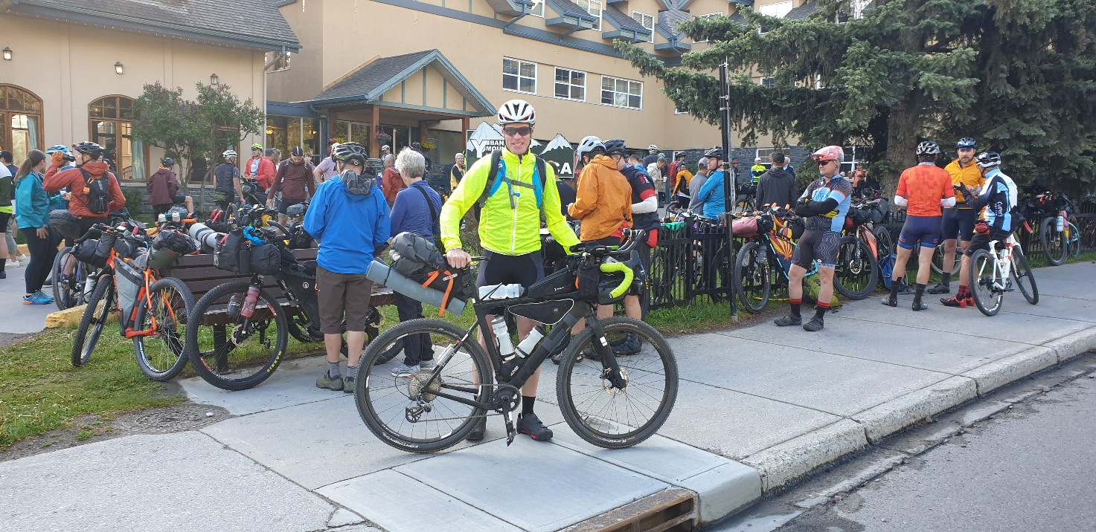
The scenery on the first day was just as breathtaking, as I had imagined and hoped for. The vast horizon of pine trees, the monstrous rocky mountains, the endless gravel riding on both big, wide gravel roads and on singletrack combined with the feeling of solitude made the day go by quickly. When I reached Fernie at 22.00 o´clock I felt both fortunate and privileged. And the day after, and for the next two weeks at least, this adventure would just go on. I couldn´t wait.
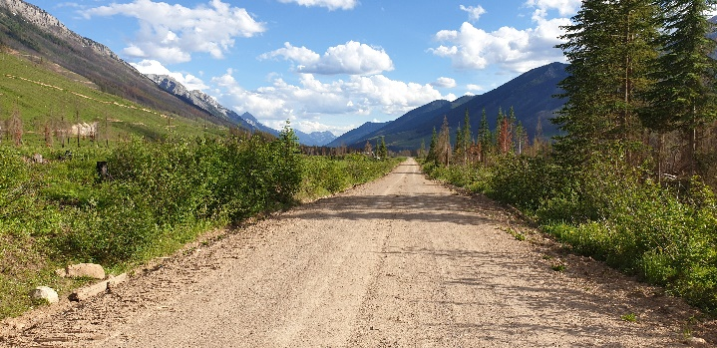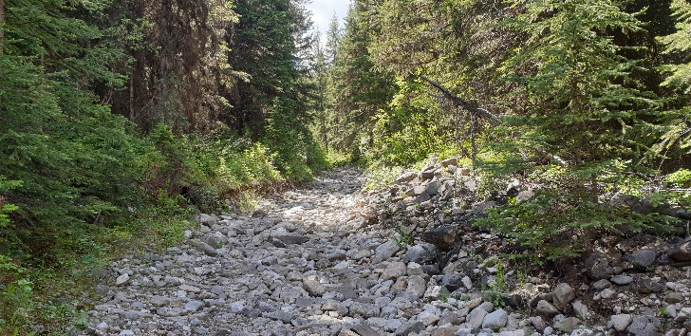
DAY 1
After a stay at the Snow Valley Hotel I got up at 4.00 o´clock. After having a stop at the local 7-Eleven I was off. The day was to take me over several passes, among these Cabin Pass and the Galton pass.
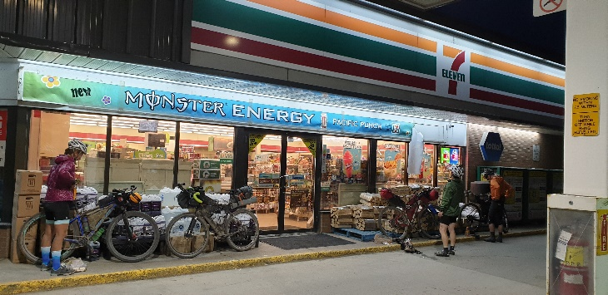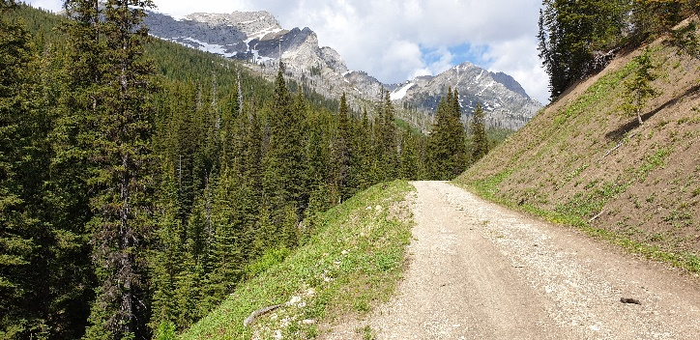
In between those two passes was the infamous “The Wall”. A very steep 3-400 meter hike-a-bike climb with your bike. Not an easy task when your bike weighs 18 kilo. At the time I thought back at the people I met in Banff with bikes weighing 25-28 kilos. Man, were they up for a strenuous walk.
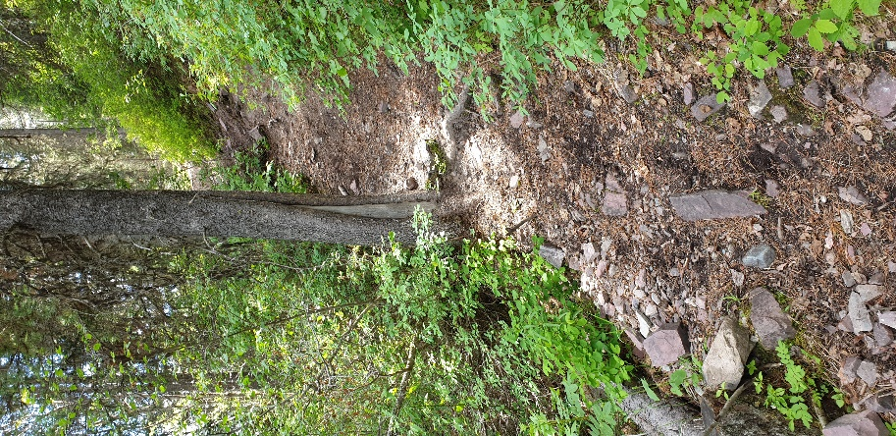
Crossing the border to the US after about 420 kilometers was a great milestone. The first difficult part of the race had been tackled, and with some really difficult technical and physically parts, I had had a good start. My spirit was high. Maybe I wasn´t in such a bad shape after all. I had no idea where in the standing I was. But at this stage of the race, I didn´t mind. I knew it was about keeping my own pace in the first week and to make sure I got enough food and rest. Then I could look at the standing when the first week was done.
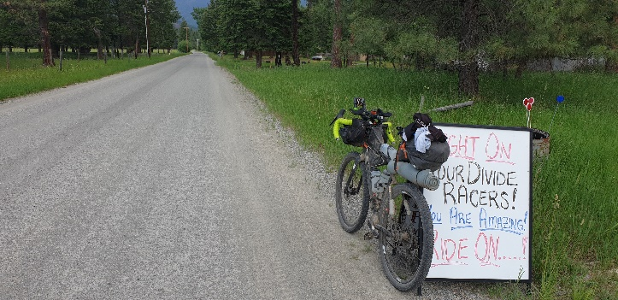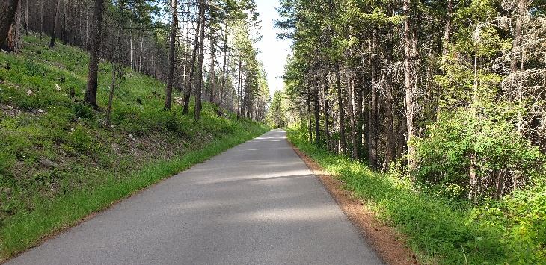
At the end of this second day I had planned to stay at the Sondressen Community Center. That would leave me with 280 kilometers for the day. After having realized I had missed the center, I headed instead for the Red Meadow Lake Campground. On the way I had my first bear encounter. Coming across a bear had been a great concern of mine, but apparently I had no reason for this. A big black bear was strolling along about 75 meters ahead of me. With my right hand already on my bearspray, I yelled at it. Within an instant it took off like a little scared cat. I couldn´t help but laugh a little to myself. Was that really it? Was that really, what I had been afraid of. A little while later I would come across something that was more dangerous, though.
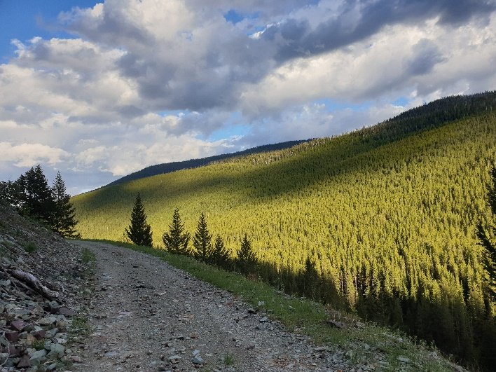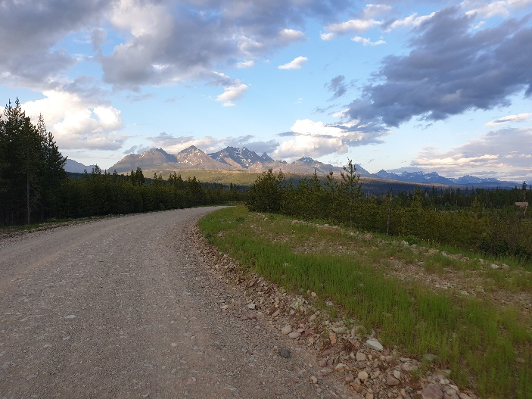
Making my way up the mountain to the campground a heavy rain suddenly set in. I put on my rain gear and rode the last 8 kilometers to the top. Finally making it to the campground, I saw a tent pitched. Asking for advice I was told, I should move on to the next campground. It was around 23.00 o´clock, it was rainy, it had become quite cold and I was riding in one of the most densely populated bear areas in the world. I didn´t really feel like moving on, so I asked, if this wasn´t a public campground. I was told, I freaked out their kids. I tried to tell, them I was just a cyclist trying to find shelter. But there really was no room for arguing with this family. After a brief conversation that turned into a heated discussion, the man became extremely aggressive. After I had said “Jeezz” the man replied “I´ll f… coming out and make you see Jesus Christ”. And while the woman was screaming “Jesse, don´t do it. Don´t do it, Jesse” as he was unzipping the tent I feared the worse and took off. Quite shocked I went down the hill, turned on my Bluetooth speaker and descended the mountain. After a 340 kilometer long haul that ended at 2.00 o´clock in the morning, I slept in a bush on the other side of Whitefish, Montana.
DAY 2
To say the least, I didn´t sleep well that night. After about two hours of sleep I woke up to my third day and headed towards Ovanda, about 275 kilometers down the trail. The profile for the day wasn´t too bad, but the weather had turned really warm, close to 30 degrees C. At a point I was low on water, and I wanted to get some from a stream. To my great annoyance, I realized I had lost my water filter. Preparing for the race I had many thoughts on how to get organized, so incidents like this wouldn´t occur. I was mad at myself, but I also knew, that it´s part of the game: You make mistakes in these sort of races. You just need to handle the consequences. For the rest of the race, I just needed to be careful to bring enough water. Some kilometers later, I did manage to find a house, where I could get some water.
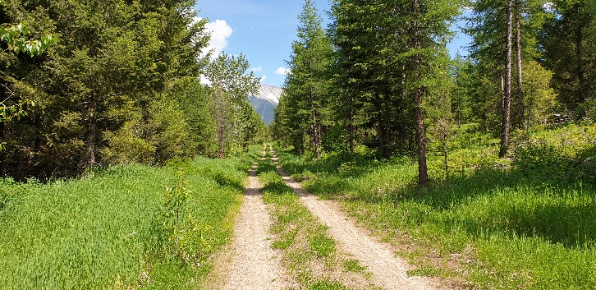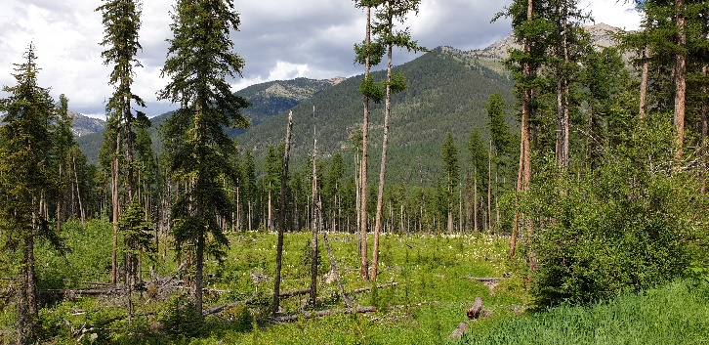
Before Ovando, I had to climb Richmond Peak. The climb was beautiful, but as I approached the top, the sky turned more and more looming. Dark clouds were closing in on me, and I could hear thunder on both sides of the mountain. Soon the rain set in. Besides bears, being caught on a mountain in a thunderstorm was another thing I really hadn´t been looking forward to. As the adrenalin kicked in I was riding at race speed towards the top. The last part of toward the top was along a narrow singletrack. The view was stunning, but the sky turned ever more threatening. I was pounding my bike through the rocks on the track, occasionally yelling “Yo bear” to avoid any unfortunate bear encounters. Once I reached the top, the rain had gradually stopped. I was reliefed, that I once again had encountered and overcome one of my fears prior to the race. Now there just was muddy descent, before the last stretch towards Ovando.
As I approached the village I was overtaken by another rider. He seemed to be determine to make a distance to me, and I could feel my competitive side taking over. The last kilometers before Ovando went by quickly. As we entered the village we had started conversating. He told me his name was Chris. Christopher Seistrup. We both had had our eyes on Ovando as our destination for the day. Before going to sleep we went to the nearby stake house. I found Chris´ pretty cool and enjoyed his company.
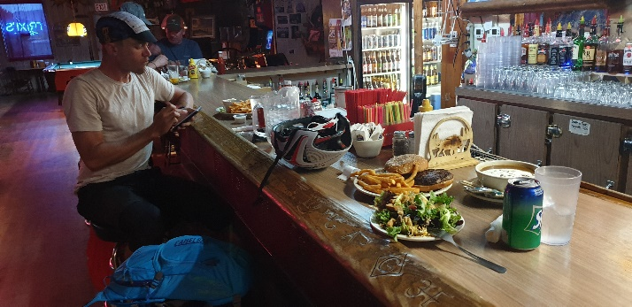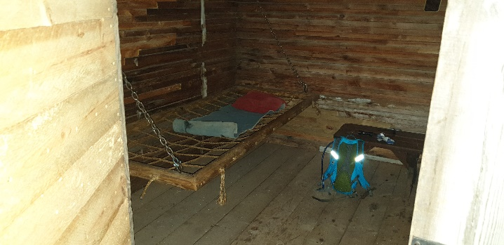
DAY 3
The morning after we left Ovando at the same time. As we hit our first ascend, we were still going close. On our descend towards Lincoln we once again conversated. Chris told me about me his last name which has a Danish resemblance, about his hemophilia disease and how he was collecting money for others with the same disease.
As we entered Lincoln we both stopped at the local gas station for resupplies. Resupplying always was both a joy and a burden. Running low on fuel is not something you want to do in Tour Divide, and the shopping was always something I looked forward to, although I pretty much always bought the same: Starbucks ice coffee, Hersheys chocolate, nuts and some other chocolate bars. This time was no different, except for a couple of burritos. One to eat and one to go.
Chris left minutes before me. I always enjoyed some occasional company, but I also liked the solitude. For the rest of the day, I would see Chris on and off. The next summits on our way to Helena were sometimes grueling. The steep ascends in combination with loose gravel made it hard. I often thought what I would pack differently, should I do this race again. I sure would skip a thing or two to make my bike lighter. On these climbs every gram lost would make a difference.
On the last climb before Basin up Lava Mountain we once again were riding close to each other. At a point I had to stop, and Chris went on. On top the very technical Lava Trail hit. The part seemed to go on forever. Time was flying and suddenly the day turned into evening. At this time I started to feel the pressure. It was about to get dark and the temperatures dropped. All of a sudden the rain started pouring down also. Like that wasn´t enough, my navigation device was running out of battery as well. And since my backup navigation, my phone, had also run out, I was desperate to get down the mountain quickly.
Finally the trail came to an end. As the dark set in I was racing down the mountain in the rain not wearing my rain gear. When I reached Basin I had no idea where to go. The local restaurant still seemed to be open and with great relief I entered. There I found Chris with a big smile on his face. We had a meal together and Chris took off. A little shocked by the situation I had put myself in, I stayed at the city hall to dry up and recharge my devices. I was determined to find a solution for my poor power resources the next day. As I was just about to fall asleep someone hammered at the window. It was Kim Raeymakers who had made quite a comeback after breaking his seatpost after only 200 kilometers of the race. After he had settled in, we went to sleep.
DAY 4
The next morning, on the fifth day, we left the city hall together. As we reached Butte, we split up. I went to Walmart to get a powerbank and other resupplies. Soon after I was heading south.
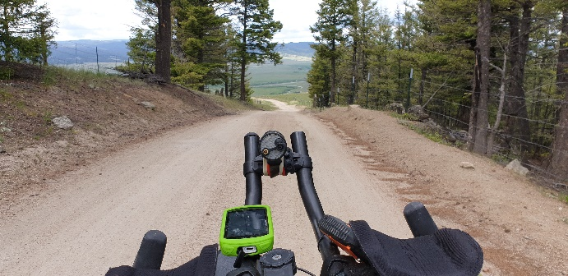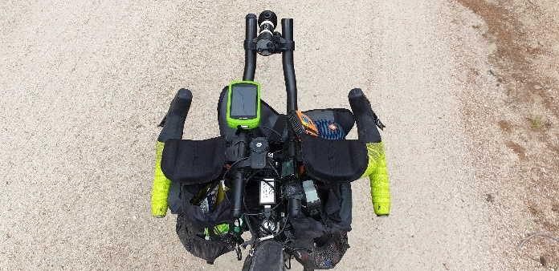
The first real challenge coming up was the Fleecer Ridge. Even though I had heard rumors of this dreadful descend, the scale of it still surprised me. From the moment I tried riding my bike down through the big rocks, I knew it was a bad idea. The crash was unavoidable. After having my bike taking several somersaults, the first one on myself, I chose to descend the hill by foot. Even that was at times challenging.
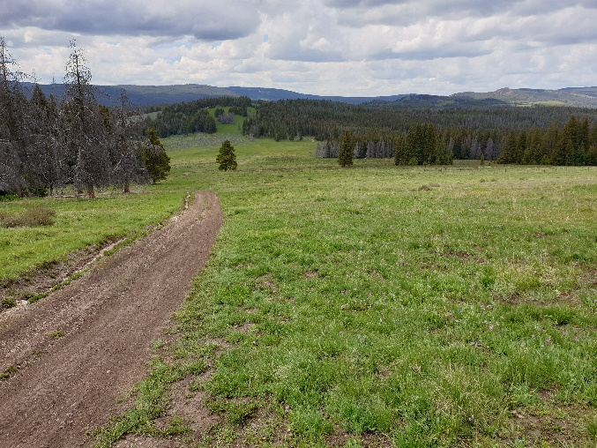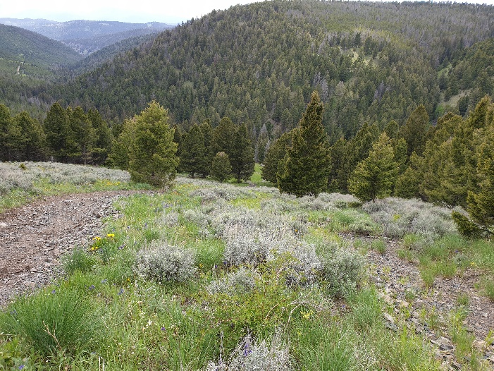
For a northern state, the temperatures really surprised me. With temperatures close to 30 degrees C, and with a strong headwind, I was struggling a bit going up the Pioneer Mountains Scenic Byway. Going down the mountain I met John, a 60-year old tourer going for a week long round trip. For as long as it lasted, I enjoyed his company. His appearance was that of a tourist, his legs weren´t. I thought I was going at quite a decent speed, and the old chap kept hanging in there for a nice conversation. 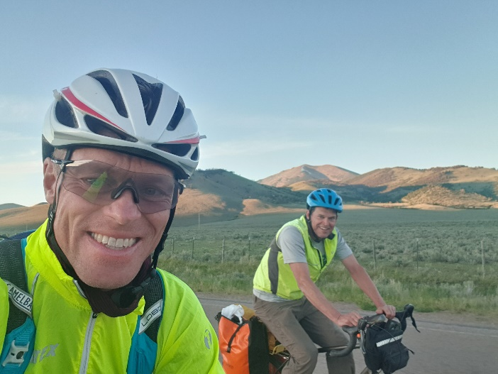 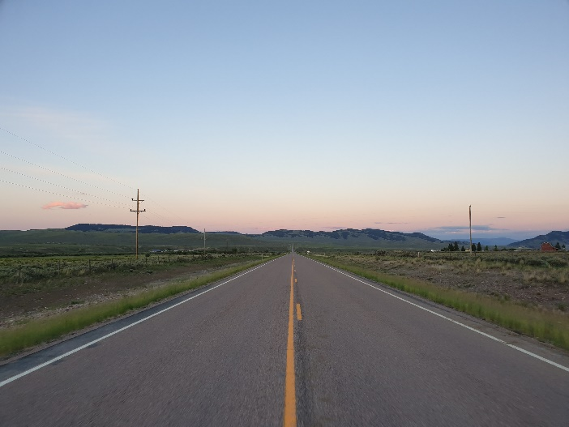
Taking the right turn down the old Bannack Road ended the brief companionship. At the time I still felt up for getting in some distance for the day, although the dusk was setting in. I ended the day in ditch next to a house going up towards Ayers Canyon.
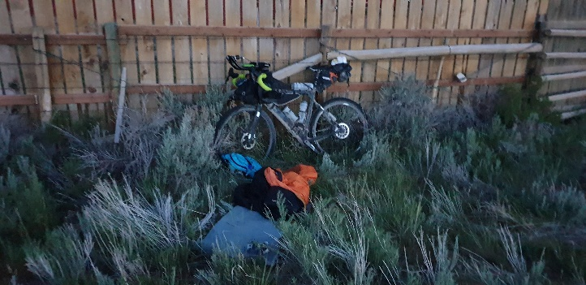
DAY 5
Waking up the next morning was tough, and it took a while to get the legs going. The breathtaking views helped getting me along. Of all the states the Tour Divide runs through, Montana is probably the one, that blew my mind the most. And just as grueling the old Bannack Road can be during rainy, and thereby muddy conditions, just as beautiful it is during sunshine. Moving from the vast horizons of infinite beauty, just as breathtaking it was riding through the rocky landscapes of Sheep Creak.
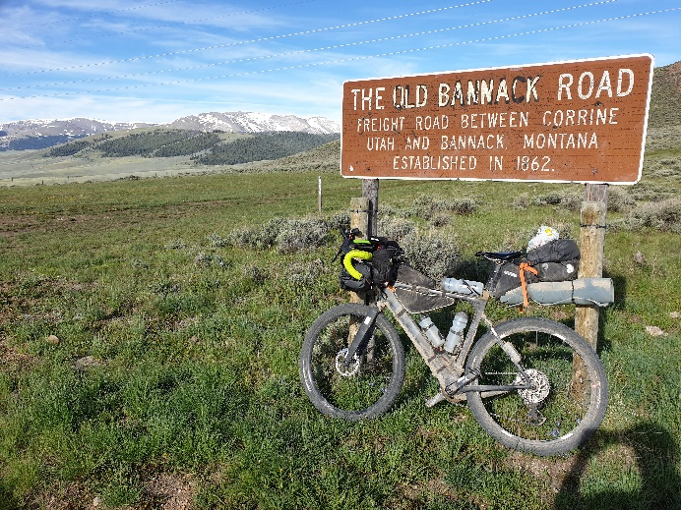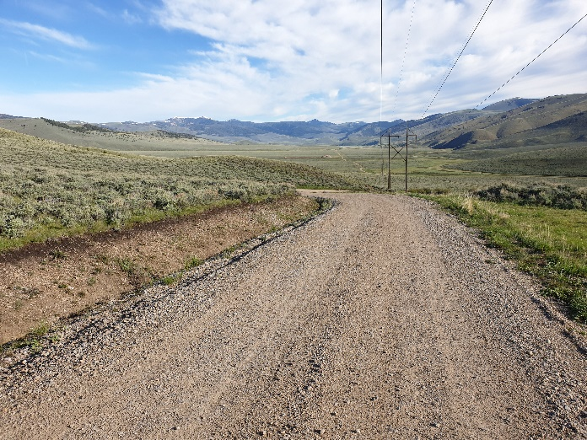
Maybe it was because of this, but as I moved on towards Lima I started running out of water. The last kilometers going to Lima therefore seemed endless. When I reached the village I went for a burger, a coke and resupplies and I was off to Idaho.
On the way all of a sudden a front came in. Thunder and rain soon took over. I put on my rain gear and almost immediately after I crashed going through a mudhole and I tore my rainpants. I was pretty upset. It was by far the first time I crashed. Every time the left knee took the blow. Fortunately, I was lucky to miss the worst part of the rain. For now. I could see the front coming from behind in my direction and for a while, it seemed I was racing the clouds. Eventually it got to me and soon the whole sky was just grey.
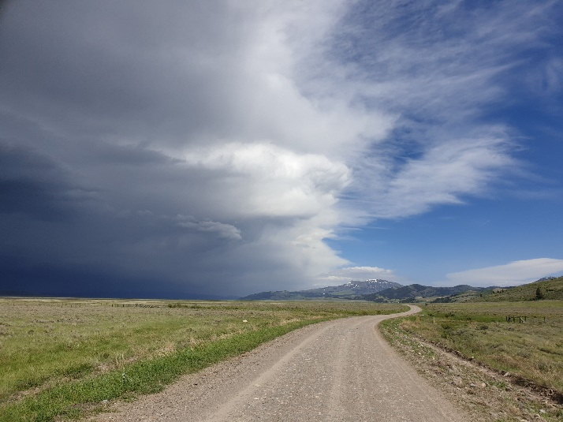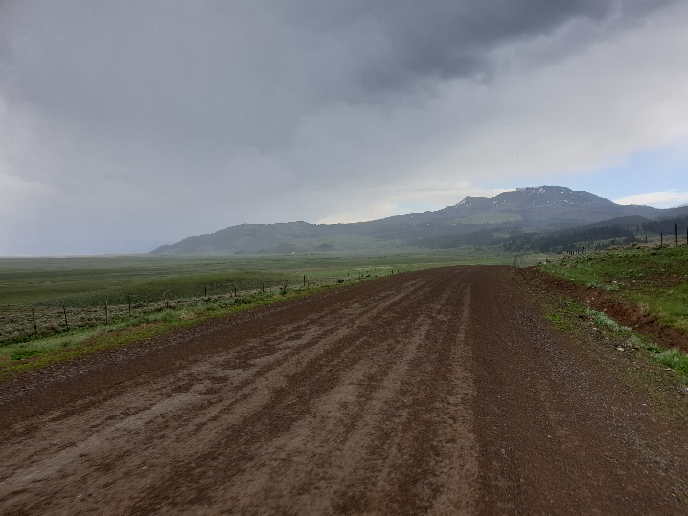
Then my new worst enemy showed up: The clay. It came like a stroke of lightning. Suddenly my bike just wouldn´t move. There really was no warning. The clay had totally clogged up at the crank. There was no way I could make my rear wheel turn. Admittedly, there is next to no clearance on my bike running on 2.2 tyres. All I really could do was to scrape off the mud with a stone, walk with my bike in the grass next to the road and hope for the roads to dry up. So I did. Fortunately, after about half an hour it did clear up, and I could continue. From this point it wasn´t the bears nor the thunderstorm I feared the most. It was the clay.
Mayby it was because of my weary sleep the night before. Moving on to Big Springs, Idaho, my speed dropped significantly. I was cruising with no real destination in mind. Once again Kim showed up. After a brief conversation we rolled into Big Springs together. We talked for a while about getting a room together. After a meal at Connie´s, it turned out, there were no rooms available, except some darn expensive ones. We chose the porch outside Alpine Inn. A little later Lucas Ratliff and Bear Stillwagon showed up. I´m pretty sure I fell a sleep in the middle of a conversation with them. I was tired.
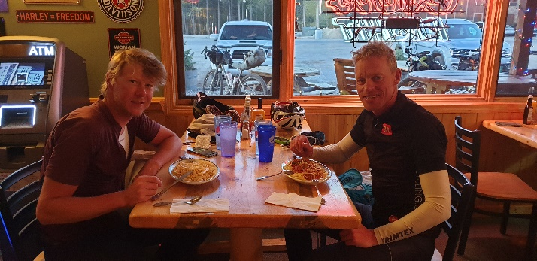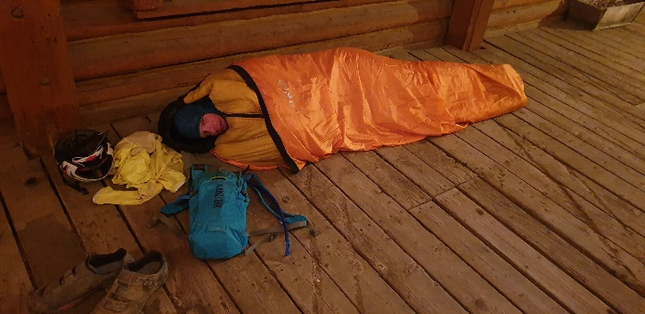
DAY 6
Kim and I both woke up at about 4.30 the next morning. After only a mile or so we hit what seemed to be an ATV track. The surface was mostly black, loose sand making it difficult to pick up a good speed. Soon we had spent two hours on the track making our way into the Yellowstone National Park. On the way we met Stefano Roumaldi, who had been riding through the night.
Having started early making it to the Squirrel Meadow Cabin was nice. Kim and I went for a meal and what a meal it was. We ordered the whole lot. Pancakes, bacon, coffee, muffins. Loaded up on renewed energy we continued.
Passing through Grand Teton National Park was beautiful, although we passed it quickly. It seemed like the route was a swing around it, and a lot of riding took place on tarmac. It seemed like a rather easy day and as we rode up the Togwotee Pass, it seemed really straight forward. Both of us were planning on staying at the Lava Mountain Lodge. With a tail wind we were flying up the mountain, but we were also about to fly down, had it not been for a minor detour. As the pass was the first one over 3.000 meters, we were also met with the first hike-a-bike section through snow. Finding the route and passing through the snow was difficult and we spent quite a lot of time making our way through the terrain.
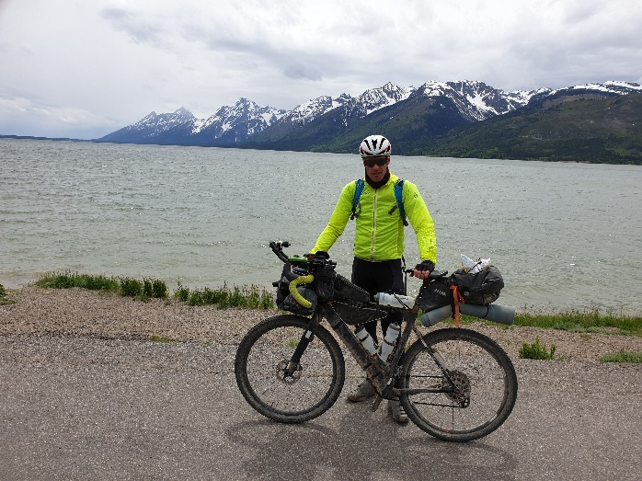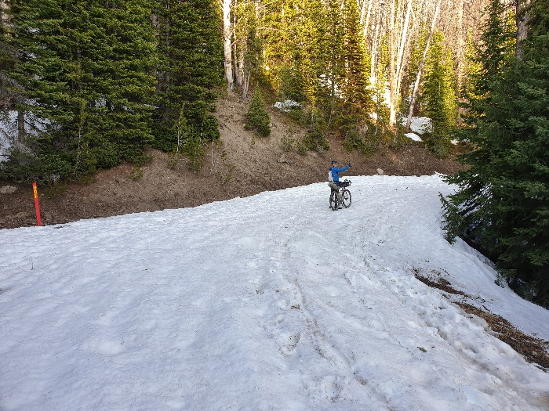
After a warm day the temperatures suddenly dropped dramatically. I had to put on a jacket to stay warm, which also meant I was left on the mountain by myself. After a very cold descend I finally reached the Lodge, where I found Kim and Lucas. A little later Bear Stillwagon would join us for a pizza. Kim and I rented a small cabin for the night. At this time, I had been dreaming of getting my second shower of the race, but this wasn´t the place. The cabin was small and spartan.

DAY 7
Kim and I got up and headed towards Union Pass at 5.00 o´clock. The morning was freezing cold. The mud stuck on our bikes from yesterdays ride was frozen, so there was no way of getting it off. I still had a little in my foodbags from the day before, so my breakfast became a small muffin, two Oreos and a chocolate bar.
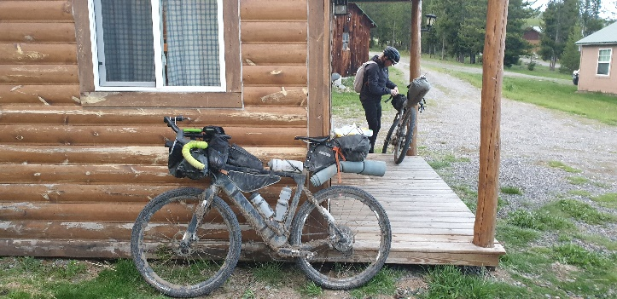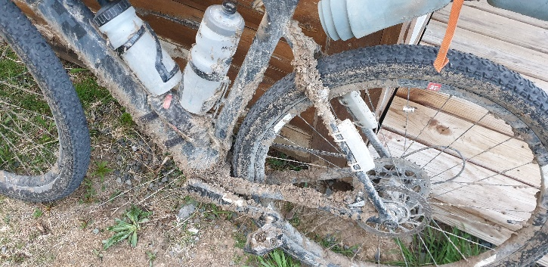
Going up the Union Pass wasn´t easy. Some very steep and rocky sections along with some snow made us go only about 40 kilometers the first four hours. Not a lot when the aim was about 280 kilometers. For the first and only time on the Tour, I had problems with my tires. I simply couldn´t get grip on some of the muddy sections. The mud made the tires feel like slicks, and I had numerous crashes. Not hard ones, but one of them severe enough to rip my rainpants open even more. I probably should had taken them off at that time, which didn´t make the frustration any less.
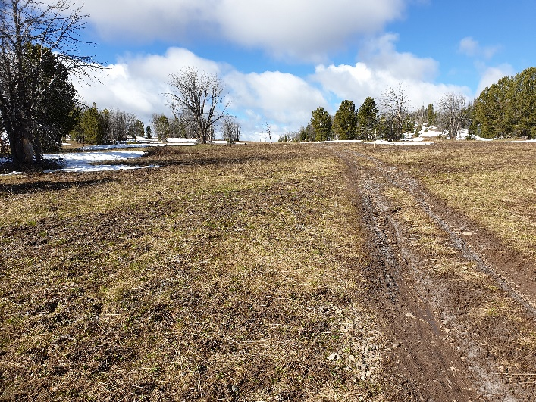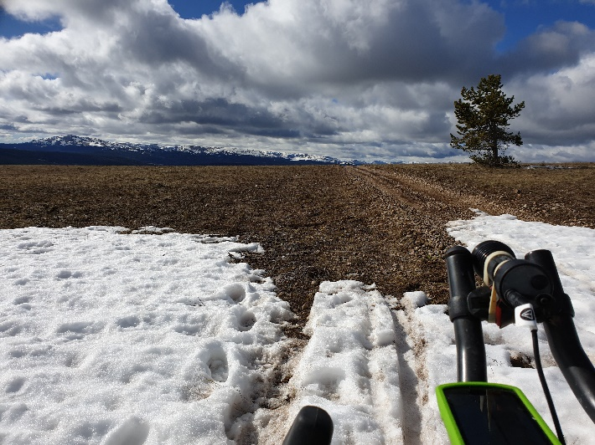
The road to Pinedale seemed much like a transportation stage. Going on tarmac, especially on the flats, always seems a bit boring if it wasn´t for the joy of getting some “free” kilometers. I had been looking forward to getting to Pinedale, but all Kim and I really did was to go to a gas station for a Subway sandwich and resupplies. Ahead of us was The Great Basin, so we knew we needed lots of fluids. The change in landscape with the vegetation, the random rocks spread all over and later the roller coaster hills made The Great Basin a great experience. I really enjoyed it.
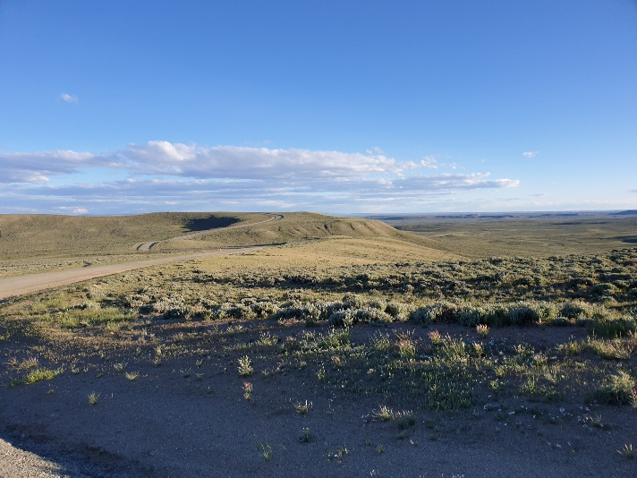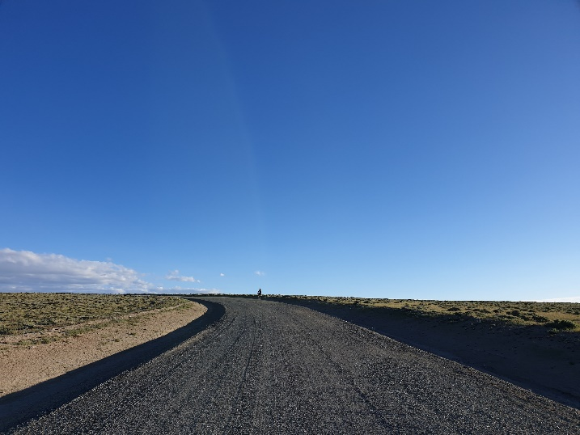
When Kim and I reached Atlantic City it was after 22.00 and the only thing we could find open was the local bar. After a long a day on the dusty roads I had hoped to get a shower and good meal. Coming in after the opening hours, the personnel in the bar only had the possibility to make us deep fried food. So I had three pieces. My body at this time was screaming for some decent food, and I have to say the chicken made me absolutely nauseas. I really could have needed a good night sleep that night. Instead I fell asleep on the porch outside the bar in close to 0 degrees C. It seemed to be the Tour Divide in a nutshell.
DAY 8
The next morning, we were five riders heading out of town simultaneously. Lucas, Bear, Kim, Peter Punnier and myself. After only about 10 minutes of riding I hit a rock. Slowly I could sense my tyre was loosing air. As I could see the other riders disappear in the distance I put in a tube. As I set off I enjoyed once again riding on my own.
For the next couple of hours, I toured the endless tracks of the basin. Soon after I could occasionally spot the other riders in the distance. Eventually I caught up with Lucas and Bear. Later Kim and Peter. And a little later Stefano. Soon we we´re riding the six of us within a short distance. Riding closely with other riders isn´t easy. All the time you have to be aware not to get too close, so you don´t draft, and at the same time not getting caught in a pace that is either too slow or too fast. Hitting Warmsutter I was a few minutes ahead of the others. At the gas station I once again bought a Subway sandwich and the usual sweets.
After a random departure we soon were riding closely together again; Kim, Lucas, Peter, Stefano and I. Bear was ahead of us. Headed towards the destination for the day we were passing through the Muddy Creek. And it sure lived up to its name. A brief shower was all it took and our bikes were totally clogged again. Because of my limited tire clearance, it seemed my bike was more clogged than the other´s. At least it took me longer to clean my bike, so I was able to get moving again.
The last stretch towards the Brush Mountain Lodge I was again riding by myself after the other riders had stopped in Savery. It was raining on and off. It didn´t take away the joy of going up the mountain. Colorado showed off the moment I had entered it. It was just as I had imagined it. Mountainous, green and with a lot of floods.
As I progressed the day was turning into evening. Just a kilometer or two before the lodge I passed Tony Lessueur. The last time I saw him was in Lincoln. When we reached the lodge we were immediately met with the comfort of the lodge and the warmth of Kirsten, the lodge keeper. I was also met with confusion. First; the other guys ahead of me; Kim, Lucas and Peter weren´t there. Apparently, they had stopped in Savery, which I didn’t know at the time. Second; a big part of the front of the race was there; Sofiane Sehili, Josh Ibbett, Lael Wilcox, Kai Edel, Evan Deutsch. Apparently, there was too much snow on top of Watershed Divide, and it didn´t seem possible to pass.
Being in the lodge was strange, mostly in a good way. It was nice and comfortable. Almost too comfortable. It was nice to be able to rest, to eat, get a shower and get warm. And it was nice to spend time and get to know the other riders. They were all great people. But at the same time, there was this attitude “The race is over”, and a lot of the riders spoke about quitting the race and just tour the route. It was easy to fall into comfort and just kick back, so for a lot of the time, I tried to keep a distance. I knew, this could be my one shot at doing the Tour Divide, and my main concern was if I would still be able to catch my plane leaving from Tucson exactly three weeks after race start.
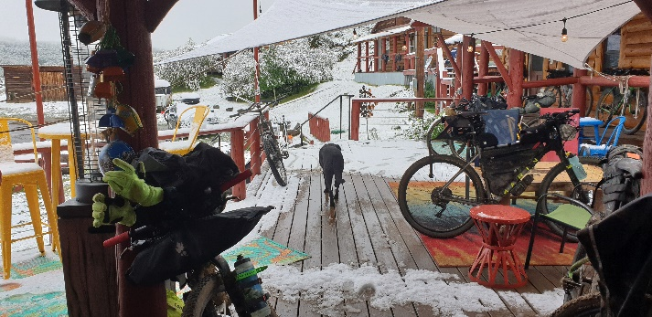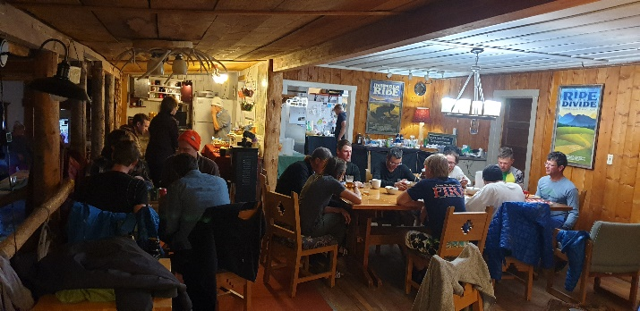
DAY 9
We stayed at the lodge the next day. I wanted to make sure, there wasn´t coming any more snow. Going over the pass in alpine conditions with the very limited equipment I had brought, sounded risky, and I didn´t want to jeopardize my safety. Especially not after the stories we heard from the riders in front, who talked about very difficult conditions.
I was determined, though, that I wanted to finish the race. Other riders felt the same. Lucas, Stefano and I discussed when it would be the best time to leave the lodge. We all agreed that 3.00 o´clock would be a good time. By that time the mud on the road going up would hopefully be frozen, if not dry, and snow would still be crisp passing the top. And we would be able to hit the sunrise going down the mountain. So the day before we tried different solutions on how to carry our bikes if we had to. We unloaded as much of our belongings from bikes and put it into backpacks and used sparetubes to carry the bikes almost like shoulderbags.
DAY 10
So at 3.00 o´clock we got up, and at 3.30 we took off. Tony Lessueur and Bear Stillwagon had decided to leave the lodge at the same time. The plan seemed to work. The road had pretty much dried up, so we never got to use our carry systems for the bikes.
The hike-a-bike section through the snow wasn´t as bad as I had feared. Thanks to the four guys who had gone ahead the day before, we could follow their tracks. It was with a certain relief I descended the pass. Mostly because I once again seemed to able to finish the race.
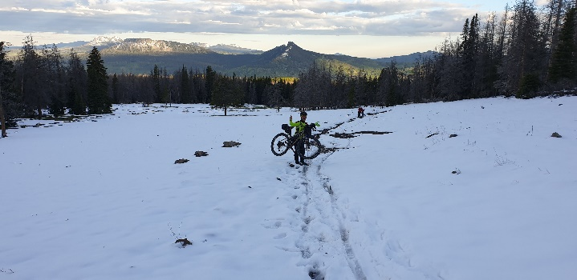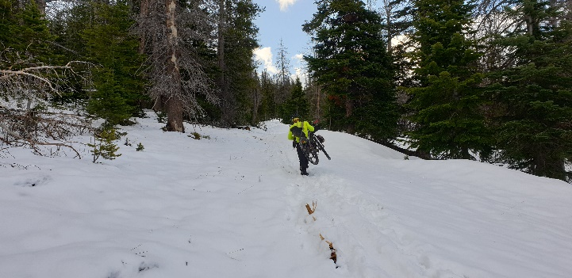
On the road leading to Steamboat the five of us got split up. Lucas and I were the ones to hit the city first. We both needed to have mechanics fixed so we went to get that done.
Moving on to Lynx Pass was with a certain excitement. The day before I had seen Chris Seistrup, who was now ahead in the race, report on Facebook that riders had to pass a “balls high” stream. And it was true. Lucas and I were still riding close, and we hit the stream at the same time. Mostly it was just nice with a cool shower to the legs.
After resupplying in Kremling and a heavy rainshower we caught up with Bear. When we hit Silverthorne we decided to book a room together. Finally, I was able to get a shower and to properly recharge my devices.
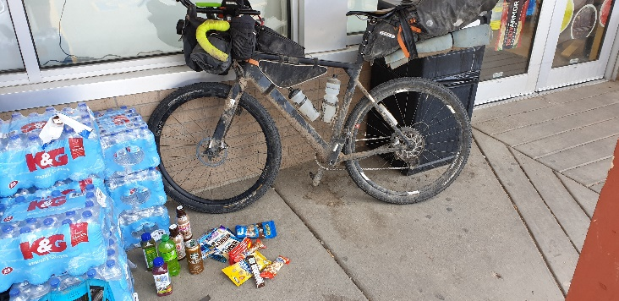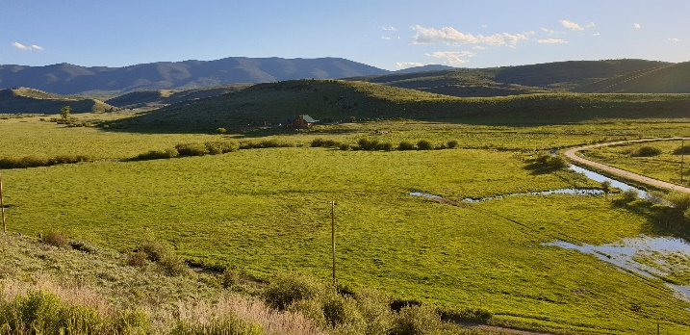
DAY 11
Leaving the next morning we went through Frisco and Breckenridge. I had to resupply so I went up the Boreas Pass myself. When we reached the top I had caught up with Lucas and we descended the single trail close to one another. When we reached Hartsel we decided to go for a bite at the local restaurant. Just as we entered the city, we could see a rider leaving it. We couldn´t see who it was, though. We quickly found out. At the restaurant we met Josh Ibbett. All day he must had been right ahead of us. With him was Kai Edel, the rider leaving the town. It was nice to sit down for a chat. Josh left after a short while. Bear had to get water, so Lucas would hold up for him. I told him I would just roll on.
As I was riding, I once again enjoyed finding my own rhythm. I didn´t really think much, I just went. After half an hour I could see a rider in front of me. I caught up with Josh. I couldn´t really figure out, if it was him going slow or me going fast. I didn´t give it any further thought. I passed him and pushed on. After another half hour I caught up with Kai. That surprised me. He was way ahead of me just an hour or two before. I felt good, in fact I hadn´t felt better at any time earlier in the race.
From this point I was no longer touring, no longer afraid of leaving myself as a wreck at the end of the day. I just went with the feeling and the pace that felt right. From this point I wanted to push, and I wanted to push the rest of the way to New Mexico. Finally, I felt I had the legs to race even though there was still 1.600 kilometers to go.
I checked and could see, that I was in 7´th place. Four guys were way ahead: Chris Seistrup, Josh Kato, Nate Ginzton and Steve Halligan. In 5´th place was Tony Lessueur, who had passed me at night in Silverthorn and Stefano Roumaldi. I decided to go for 5´th place. I knew it would be tough. Both Tony and Stefano had been riding strongly, and they seemed to able to go without much sleep.
As I reached Salida I decided to go to Walmart. I still had problems having enough power for my devices, and I figured I would still be able to get over Marshall Pass before it become dark. Unfortunately, it was an hour lost. They didn´t have the powerbank in Walmart. Instead I stocked up on the usual resupplies and I was off. The climb up the pass was amazing. The dusk set in but the temperature was nice and the views were stunning. I felt great. Going down I caught up with Stefano. We descended the mountain together reaching Sargents at around 0.00 o´clock. I slept outside the café.
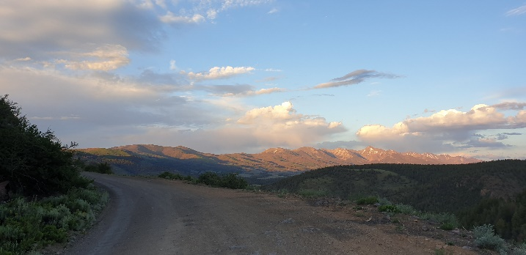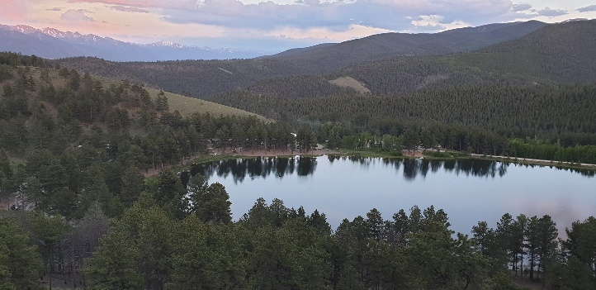
DAY 12
Waking up the next morning at 4.00 o´clock I had a strong feeling, I was already trailing behind Stefano, who had been sleeping behind the café in the bush. Tony was way ahead. It took me quite a while to get the legs going. Fortunately, it was mostly downhill. Passing the Dome Lakes I was running short on water. Still ahead of me was Camera Pass before I would reach La Garita. I was trying to drink as little as possible so when I got to where I expected La Garita I was really thirsty. To my surprise I could not find La Garita. I never really found out, if it was a small city I had just passed through without noticing or just an area. Nevertheless, I had to realize, that the next water supply coming up would be Del Norte some 30 kilometers ahead. I was absolutely desperate. The last singletrack section before Del Norte distracted me a little from my thirst, but soon I was met with a head wind that was so strong, I could only go 8-10 kilometers per hour.
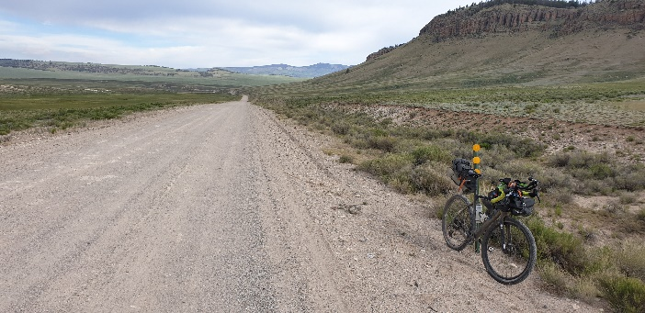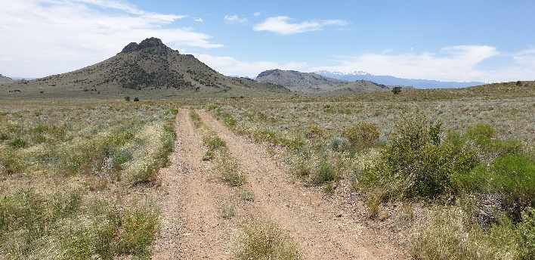
When I reached Del Norte I pretty much stumbled into the gas station. I was wasted. I quickly ordered my usual Subway sandwich and a drank a litre of ice coffee in seconds. It took me a while to recover, about an hour I would think. Meanwhile Stefano arrived whom I had passed ealier.
I left the gas station heading towards the highest point of the tour, the Indiana Pass, in more than 4.000 meters. I had seen, that Josh Kato apparently was having trouble and was still in Del Norte. With Stefano behind me, it meant that I was now in 5´th place.
Even though I felt rehydrated and somewhat recovered again, the Indiana pass was really challenging. The temperatures were about 30 degrees C. and the steepness of the mountain was tough. Time was flying and as the late afternoon meant lower temperatures, it also meant I would have to hurry up. I knew I had to cycle for a while at altitude with quite a lot of hike-a-bike sections through snow. Also, I knew that Tony was only three or four miles ahead of me.
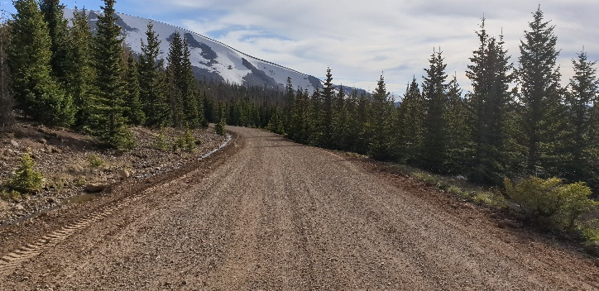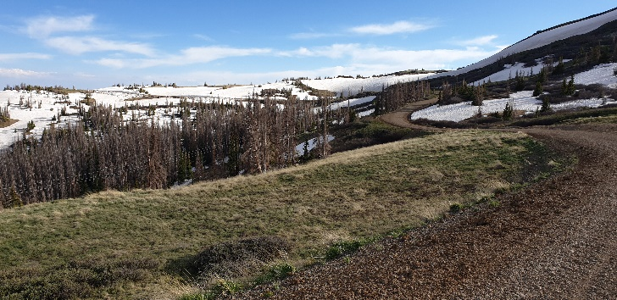
For a while I considered, if I should stay at the Stunner Campground. I decided to try to pass the Stunner Pass and make it to one of the lodges on the other side. 45 minutes later I approached the Skyline Lodge. Apparently, they had spotted me going down the mountain and as I was riding my bike coming up to the lodge, they welcomed me, and said the burger was almost ready. That was the kind of persuasion, I needed. After one more burger I was accommodated into a traditional Airstream camper. With a warm shower, a nice bed and a full belly I fell asleep with a smile on my face.
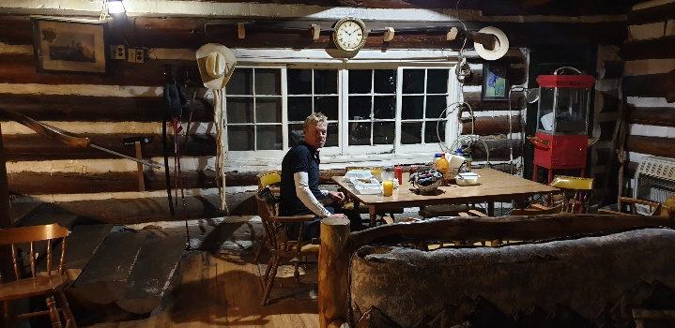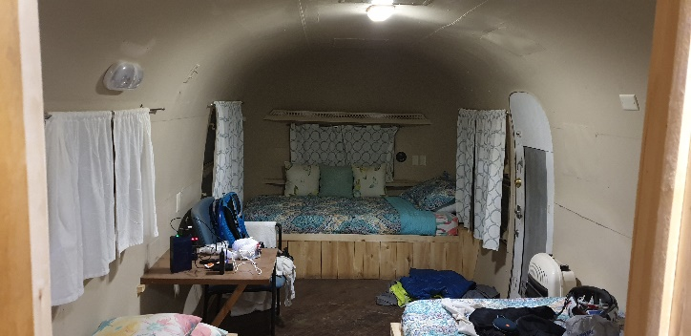
DAY 13
The day before ended with a smile on my face, and the new day started with one. Leaving the lodge heading towards La Manga Pass was all downhill. It´s always nice when the day starts with getting some kilometers in the book. As I entered New Mexico I felt, I was almost at the finish, even though there was still 1.000 kilometers to go. The rolling hills kept coming, and as the day passed I lost my rhythm. I knew Tony was somewhere not very far in front of me, but for a short while, my hunger of catching up just wasn´t there. I stopped at a house to ask for water, and seeing a hose, I decided to clean my bike. The dust was everywhere. This also meant, that I had had to oil my chain three or four times a day. While standing there a brief thunderstorm passed. With both the bike and myself having been washed, I suddenly felt I could see clear again, and I picked up the chase on Tony again.
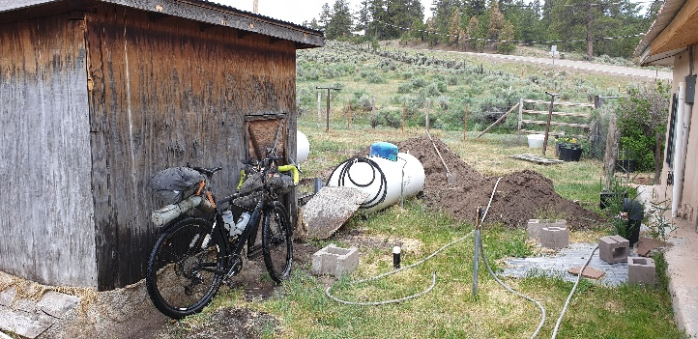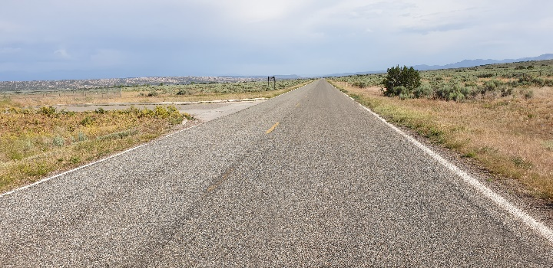
Leaving the Rocky Mountains on my way down to Abiquiu felt great. With the loss of altitude and the significant increase in temperature, I really could sense, that the race was about to go into its final phase. When I reached Abiquiu I met Tony at the local grocery store. We had a nice chat. No secret race plans, just a nice open talk. Tony decided to take off immediately. I wanted to stay a little to get filled up on energy and wait for the temperatures to drop.
About an hour later, I took off. The two step ascent was a peculiar experience. On the first I felt really good. I enjoyed the climb. The second section was probably one of the worst climbs, I´ve ever done. The loose sand, the long sections of “stone dunes” and the occasional very steep climbs caused me great trouble and frustration. The climb with its 20 kilometers felt endless. I only had my head torch, which just made everything worse. I had decided, I would stop for the night, when I reached the top. I stopped a little before. It had been a long day, and I was exhausted. I fell asleep in my bivy without my sleeping bag. That was a mistake. In the middle of the night I woke up freezing. I pulled out my sleeping bag and fell asleep again.
DAY 14
Originally, I had planned to only sleep for three hours in order to be able to keep up with Tony. I didn´t. I woke up at 5 o´clock to the soundtrack of humming birds. I knew I once again had given Tony a head start.
I quickly packed my gear, had a blueberry muffin and half a Sprite and took off. The weather was once again getting hot, and as I reached Cuba, I really needed a proper meal and a lot of fluid. I went for a burger and resupplies. When I left Cuba I checked the standing and could see, that Tony was 19 kilometers ahead of me. The way towards Torreon and Grants was all paved going on the main road. That suited me well. I was flying. My legs felt so good, so fresh. Passing a convenience store halfway to Grants, I could see Tony´s bike parked outside. I was now in 5´th place.
From this point the weather changed dramatically. Riding the rest of the way to Grants there was a strong head wind with occasional showers. I didn´t really bother. I was on a roll, and I could see, that Tony was trailing me.
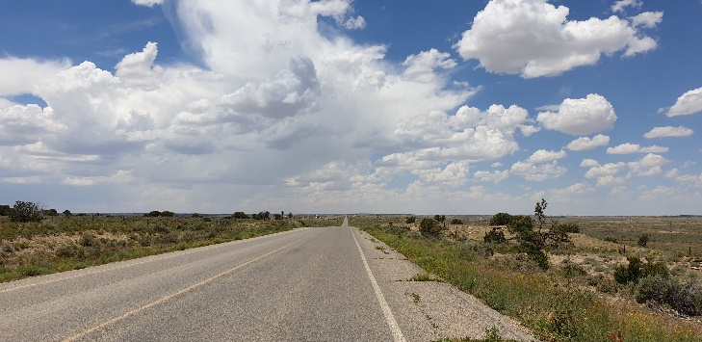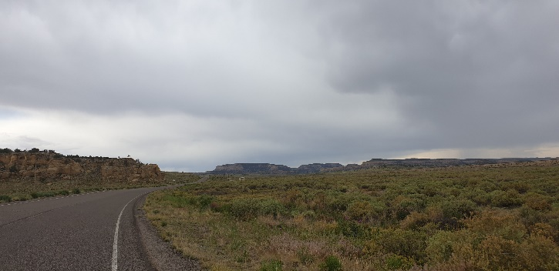
As I entered Grants I headed straight for the gas station. A subway sandwich and plenty of resupplying and I was on my way again after about an hour. When I left Grant, I could see Tony was entering it.
Heading towards Pie Town it became dark. Fortunately, it was still tarmac, and I felt good. As I turned on to Pie Town Road this all changed. The gravel was very uneven, and soon the gravel was replaced with loose sand.
Sometimes when I get tired, I loose sense of distances. This happened here. I kept thinking, that Pie Town was very close. For two hours I felt this way, getting me ever more frustrated, when it didn´t turn up around the corner.
Eventually I did make it to Pie Town. Not really having the energy to bother finding a place to sleep, I crashed on the porch of the post office. I had barely laid down, before I was sleeping.
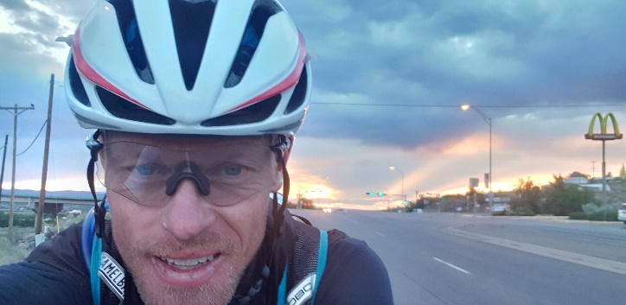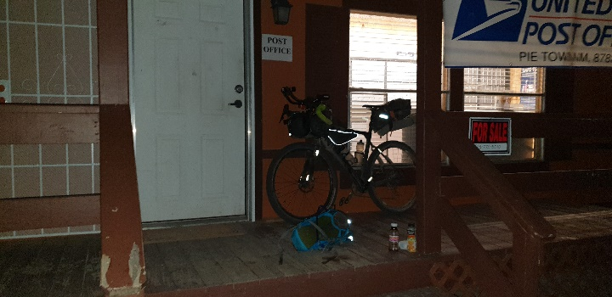
DAY 15
I had set the alarm clock on my phone for 4 o´clock. When I woke up, I had slept for two hours. I checked Trackleader.com and could see, that Tony hadn´t moved some 50 kilometers behind me. I laid down again. 15 minutes later he had moved, and I immediately got out of my sleeping bag to pack and get going.
As I was riding I couldn´t help but notice, that I had closed in on Steve Halligan in 4´th place. I didn´t really give it much thought other than that, though. I still had my eyes mostly on Tony.
The road to Beaverhead once again challenged me. The road was relentless with the washboards. And the temperature and the sun really got to me. The temperatures was reaching scorching 40 degrees C, and I felt the burn on my skin. I was getting worried about that and had to put on my loose leg on my left leg simply to avoid to get too sunburned.
Once again I lost the sense of distance, and once again the road to Beaverhead seemed endless. When I got to the Beaverhead Station I once again felt trashed. I had something to drink and a bite to eat, and it did wonders for me. To my surprise, I was told, that the guy in 4´th place had been there just 30 or 40 minutes before me.
I couldn´t really get that out of my head as I took on the Black Canyon mountains. I tried to speed up, but I could feel how the countless hills left me drained if I continued at that pace. So I slowed down. That in mind, I was really surprised when a rider suddenly appeared in front of me. It was Steve. We had a brief conversation, where he told me, he was having trouble with one of his knees. I really wanted to reach Silver City, and although I had my doubt as to whether or not I would be able to make it, I sped up and left Steve.
It didn´t take long before we once again were riding close. On the way to Sapillo campground, Steve was in front of me. Hitting the single trail it quickly became clear, that Steve was a much more technically skilled rider, than I am. He disappeared up the mountain, as I was fighting a battle with the mountain where I lacked both guts and skills. At one point, I got off my bike, and turned off all the lights. It had been a long day and I needed a short break. I sat there for maybe a couple of minutes, and I became restless. No way could I sit there being so close to the finish. I picked up my bike and continued.
I wasn´t going fast, though. I had to tackle the challenging terrain in a way so that I could somewhat enjoy it. Finally, I made to the paved road leading to Silver City, that last big city before entering the desert before the border.
I had decided I would get some sleep in Silver City. When I arrived, I changed my mind. It would be pointless, if I laid down now. Tony was coming from behind, and Steve was in fact taking a short break at MacDonald´s as well. As I was out of power, I went to Walmart to get some batteries for my head torch, and I was off.
It didn´t take long before sleepiness overwhelmed me. I had to lay down. So, I went for the ditch. I didn´t take off any clothes. Even my helmet I kept on.
Maybe it was Steve, maybe it was a coincidence, but I woke up an hour later, and felt I had to go. As I pulled my bike out to the road, I could see a tail light about a kilometer in front of me. It was Steve.
I tried to pick up some pace, and slowly I managed. Taking a left hand turn, I suddenly found Steve right in front of me. He had taken a wrong turn and was now returning back on track. We conversated for less than a minute, and I decided to stop to take off my jacket. Really it was also to make this last stretch as clean a battle as possible.
Steve was riding about 5 or 600 meters in front of me for a short while. Then suddenly I saw him on the side of the road. He was working on his pulley wheels. At the time, I felt bad for Steve. First he had had a bad knee, then a mechanical problem. He had been in front of the race for so long, and here I came with only 200 kilometers of the race to go, and I would overtake him. I know whether is is fatigue, injury, mechanical problems or whatever, it is all part of the same package. A race is about reaching the finish line no matter what obstacles you meet on your way. And Steve knew that too: “Go do, what you gotta do”, he said. And so I did. I rode my bike, like I had ridden it the last few days. I rode it as hard, as I could. Besides sleepiness, I still felt great. My legs were spinning being able to push hard. When Steve´s headlight vanished behind me, I occasionally checked Trackleaders.com. I could see, how I kept making distance to him, and when my phone no longer was able to connect to the internet, I was about 19 kilometers ahead of him. Still, I wasn´t really at ease and I kept pushing.
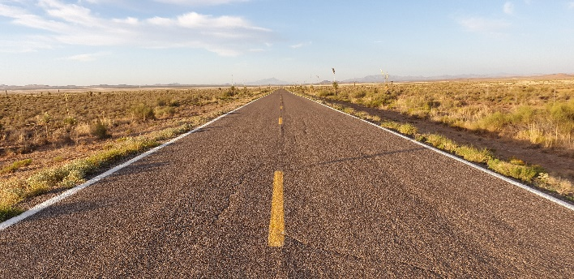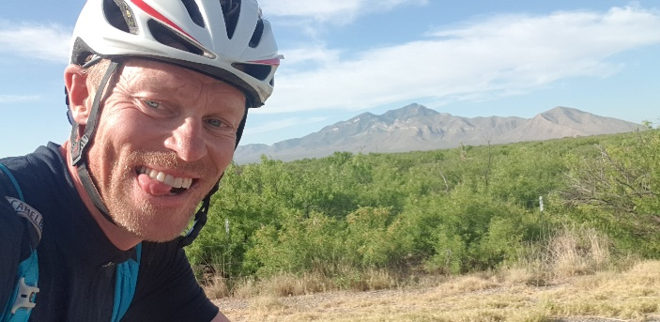
The heat quickly picked up and as soon as the sun rose it was getting hot. I still had about 90 kilometers to go and I was running low on water. I didn´t have anything arranged when I reached the border, no one to pick me up. I had been told, though to call a local in Hachita, Geoffrey, when I reached the village. Then he would pick me up. As I entered Hachita, I tried to call him. I couldn´t get the phone to connect. Maybe it was the frustration, maybe the exhaustion or the heat. Anyway, it made me miss a right hand turn. After 5-600 meters I noticed and rushed back to Hachita to get back on track. There I also met Geoffrey standing on the side of the road. We talked briefly arranging for him to pick me up. The missed turn wasn´t the worse. In the rush I also forgot to refuel on water.
After about another 30 kilometers my situation became critical. I only had half a bottle of water, the temperature was already close to 30 degrees Celsius and I still had 30-40 kilometers to go. I was absolutely desperate for water. I had to make myself drink only every 8 kilometers. I tried not to look too much on my navigation, but it was hard.
As I rolled to the fence of the border, I was overwhelmed with feelings. The end of the tour, and the end to my self-imposed misery. I sat down waiting for Geoffrey in the shade of a pillar. I was still thirsty, of course, but most of all I was just happy. The joy of reaching my goal, the gratitude of having had such an amazing experience. I sat there for 20 minutes and suddenly I saw some waterbottles marked “Divide” behind a pillar opposite of me. I almost started shedding a tear again.
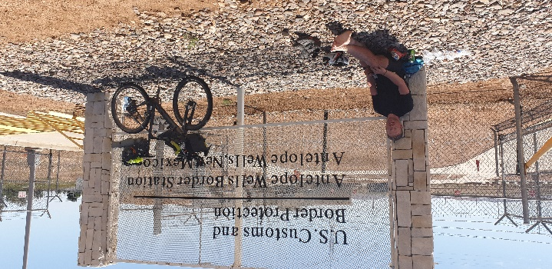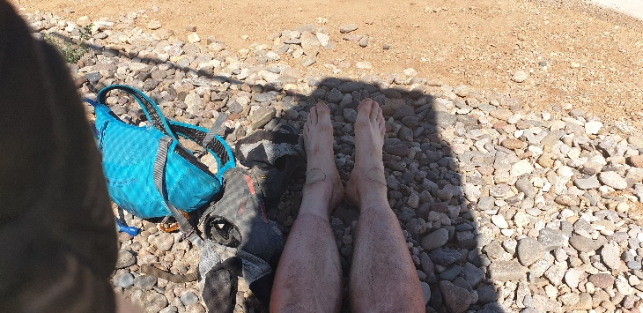
Exactly an hour later Steve came, and with him also Geoffrey. It was nice to see, he also made it all the way despite his challenges on the last section. And it was nice to talk to someone and share the experience with.
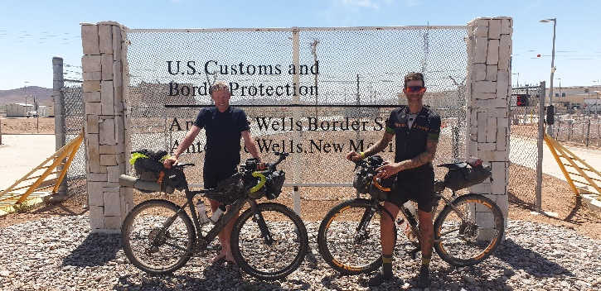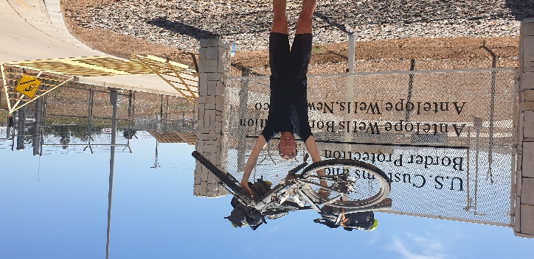
As I sat in Geoffrey´s Volvo on our way back to Hachita the tiredness hit me. It had been 28 hours since I woke up in Pie Town, and I had been sitting on my bike 27 hours since then. As the landscape passed I couldn´t help to get a little emotional again thinking about all the sacrifices I had had to make on my way to the race, all the frustration and stress both before and during the race. The relief was colossal. And at the same time, I again felt so enormously privileged to be able to do this sort of feat and so thankful to all the people who had supported me along the way.

